Pre-requisite

1 Repo

2 branches ( main, child )

1 Branch policy on Main branch

1 Build Definition ( enable CI )

1 Release definition ( enable CD)

1 Pat token to read and write on repos ( Preferred to give full access )

Release Pipeline sample Screenshot

=============================

Step 1 : Add PAT token in released definition Variables section, Add it as secret

Step 2 : Add Azure cli task and select ARM connection ( valid )

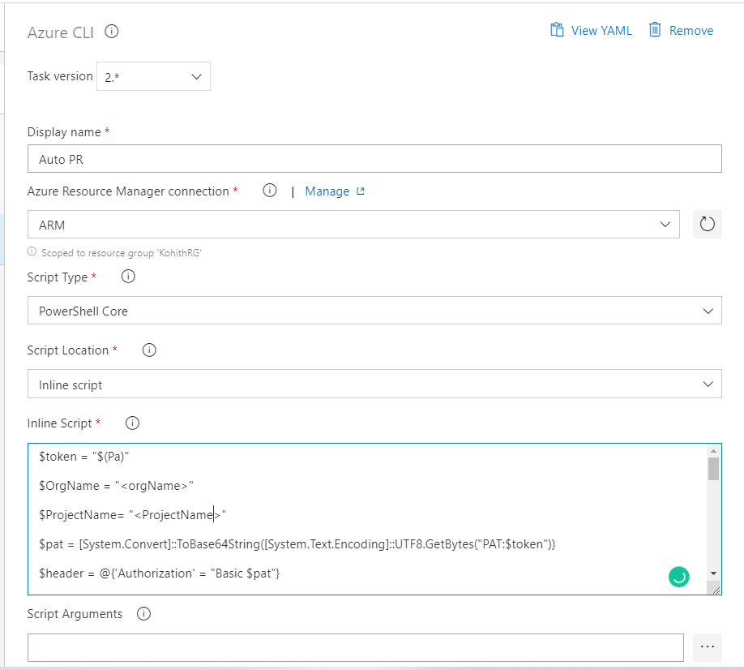

Step 3: Add Env variable “AZURE_DEVOPS_EXT_PAT” value $(Pa) {PAT token variable}

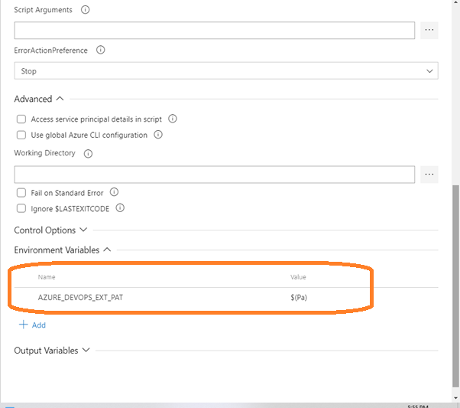

Azure CLI Inline Script

==================  
  
$token = "$(Pa)"

#Provide DevOps Organization name

$OrgName = "<orgName>"

#Provide DevOps Project name

$ProjectName= "<ProjectName>"

$pat = [System.Convert]::ToBase64String([System.Text.Encoding]::UTF8.GetBytes("PAT:$token"))

$header = @{'Authorization' = "Basic $pat"}

$ReleaseId=$(Release.ReleaseId)

#Release URI:

$RURI= 'https://vsrm.dev.azure.com/'+$OrgName+'/'+$ProjectName+'/_apis/release/releases/'+$ReleaseId+'?api-version=6.0'

#Invoke Release REST API

$ReleaseRESTAPI= invoke-webrequest -Method GET -Uri $RURI -Headers $header -ContentType 'application/json'

#Convert Result to Json format

$jsonoutput = $ReleaseRESTAPI.Content | ConvertFrom-Json

#Fetch Build Id

$BuildID = $jsonoutput.artifacts.definitionReference.version.id

#Print Build Id

Write-Host $BuildID

#Build URI:

$BURI = 'https://dev.azure.com/'+$OrgName+'/'+$ProjectName+'/_apis/build/builds/'+$BuildID+'/workitems?api-version=6.0'

#Invoke Build REST API

$WorkItemsbuildAPI= invoke-webrequest -Method GET -Uri $BURI -Headers $header -ContentType 'application/json'

#Convert Result to Json format

$jsonoutput1 = $WorkItemsbuildAPI.Content | ConvertFrom-Json

#Get the Work Items

$WitIds = @($jsonoutput1.value.id)

#print Work item/’s

Write-Host $WitIds

az repos pr create --org https://dev.azure.com/<DevOpsOrganizationName> -p "<ProjectName>" -r "<RepoName>” -s "<SourceBranchName>" -t "<TargetBranchName>" --merge-commit-message "PRCommitMessage" --work-items $WitIds --auto-complete true --delete-source-branch false